AI Lab Assignment 4.2
Task Description#1
Zero-shot: Prompt AI with only the instruction — Write a Python function to generate the Fibonacci sequence up to n terms
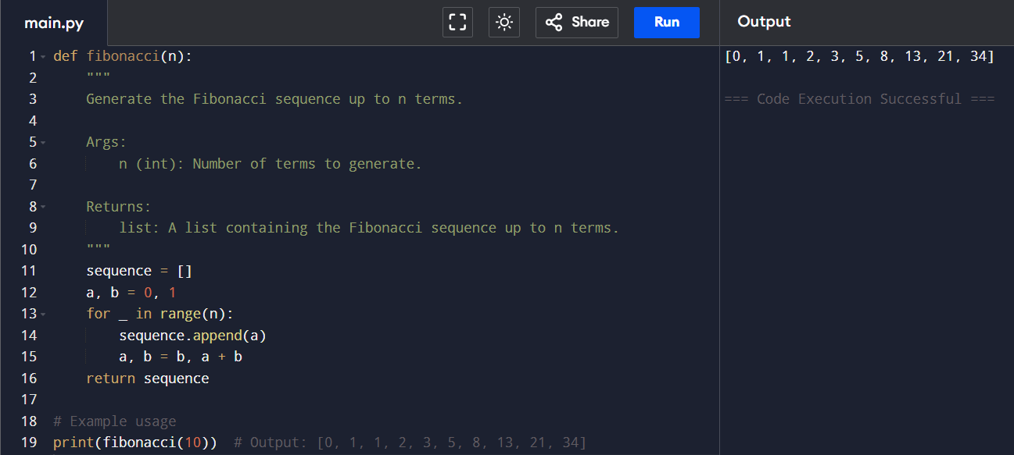
Observation
In zero-shot prompting, the AI generated the Fibonacci sequence function using only the task description.
It correctly applied the iterative approach with no examples provided.
However, since no guidance was given, it may not always cover special cases like negative inputs.
Task Description#2
One-shot: Provide one example: Input: 100, Output: 37.78 to help AI generate a function that converts Fahrenheit to Celsius.
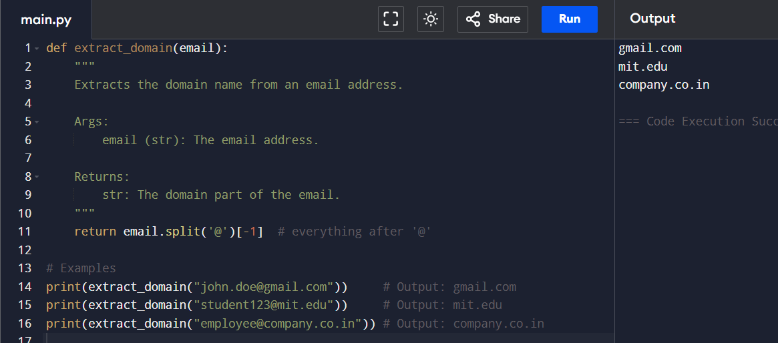
Observation
With a single example provided, the AI easily identified the correct conversion formula.
One-shot prompting gave enough context to produce accurate results.
It shows that even one example helps the AI align its output with expectations.

Task Description#3
Few-shot: Give 2–3 examples to create a function that extracts the domain name from an email address
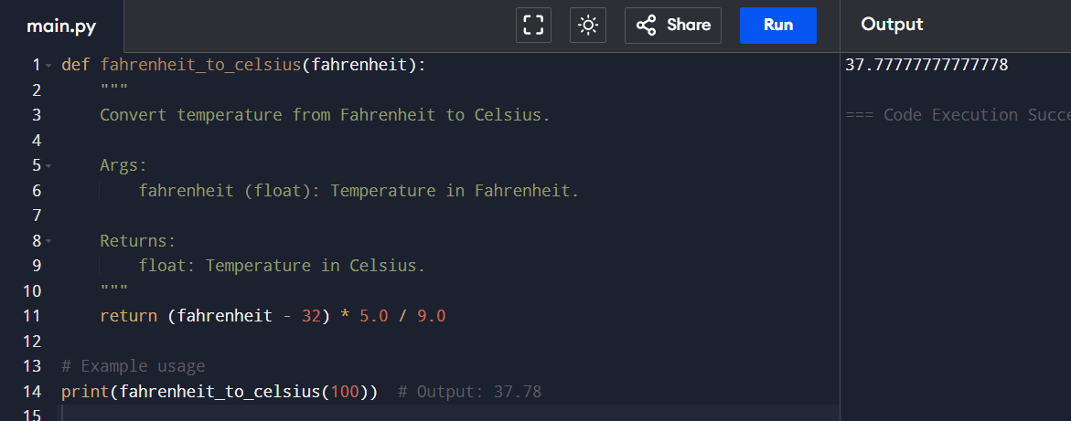
Observation
By giving 2–3 examples, the AI learned to extract the domain part from different email formats.
Few-shot prompting improved accuracy for .com, .edu, and .co.in cases.
This method ensured the function could generalize well across variations.

Task Description#4
Compare zero-shot vs few-shot prompting for generating a function that checks whether a word is a palindrome, ignoring punctuation and case.
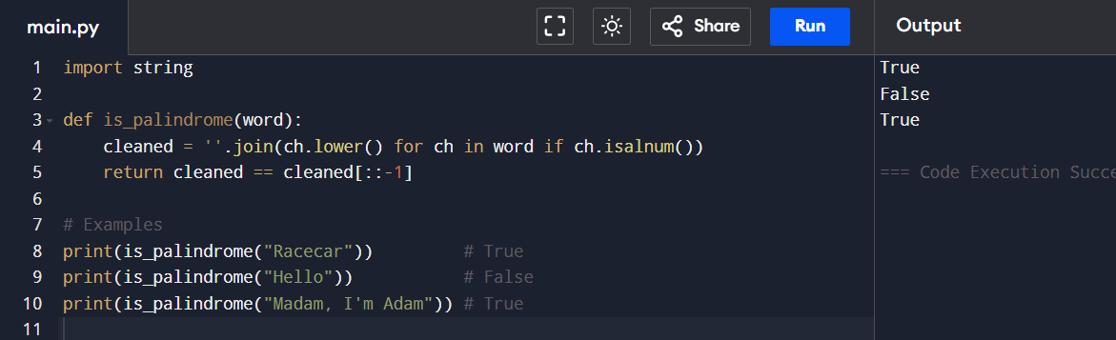
Observation
Zero-shot prompting produced a simple palindrome function but sometimes ignored punctuation and spaces.
Few-shot prompting, with examples, guided the AI to handle tricky cases more reliably.
This shows that few-shot is better when the task involves ambiguity or edge cases.

Expected Output#5
A function that handles all cases with correct logic based on example patterns.

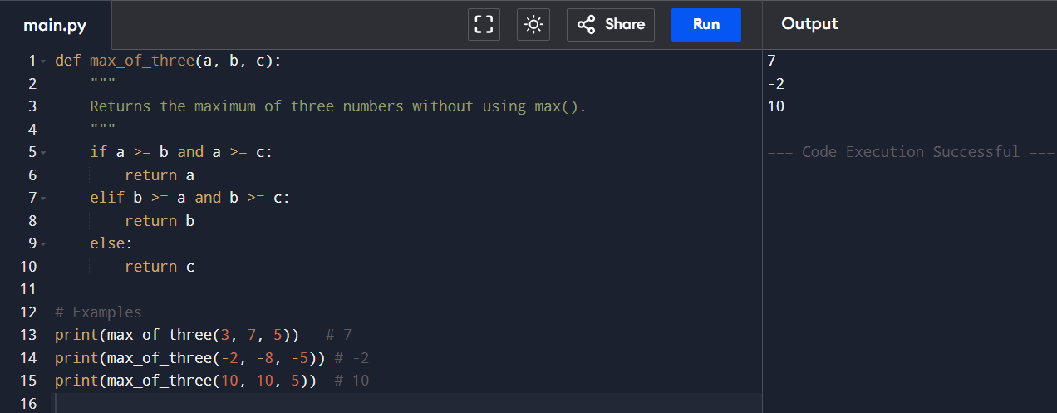
Observation
Few-shot prompting helped AI generate a function to find the largest of three numbers without max().
The examples guided it to handle positives, negatives, and duplicate values correctly.
This demonstrates how multiple examples make the solution robust and consistent.

